

**Submitted by : Spogmai Jan**

**Roll NO : 2430 - 0081**

**Submitted to : Sir Bilal Dar**

**Date of submission : 15/October/2024**

**Subject : Programming fundamental .**

**Lab Task :03**

* **Task 01: Working with different data types.**

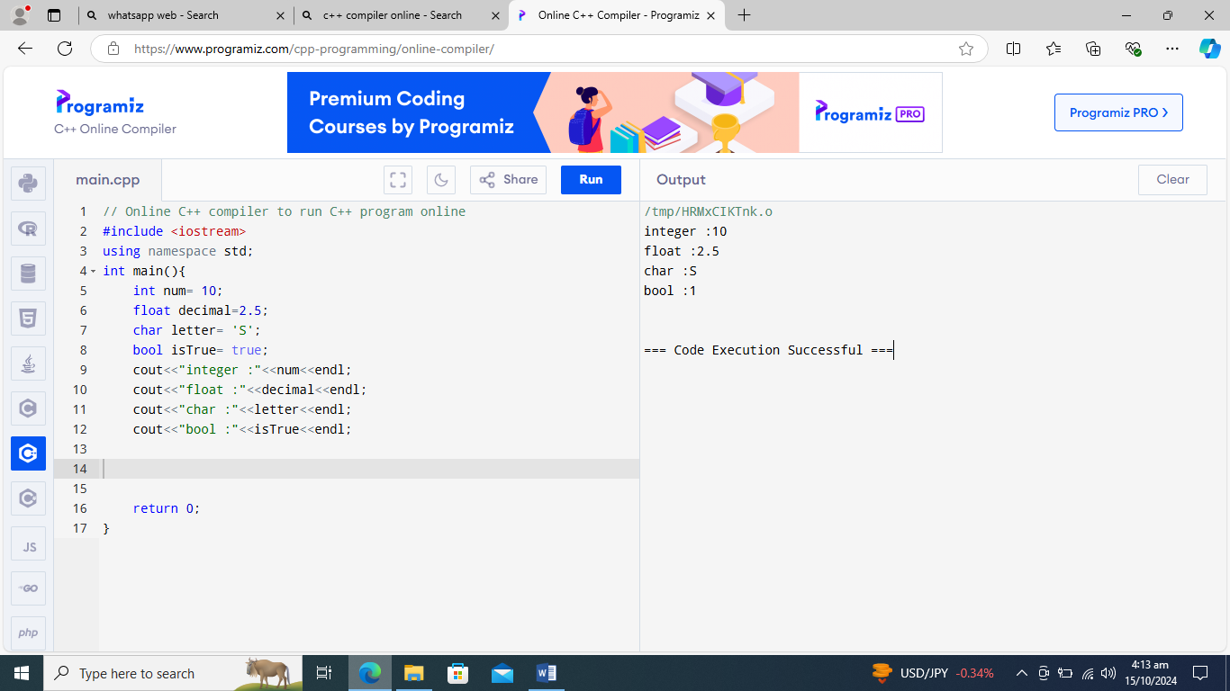

* **Task 02 : Taking input from the user.**

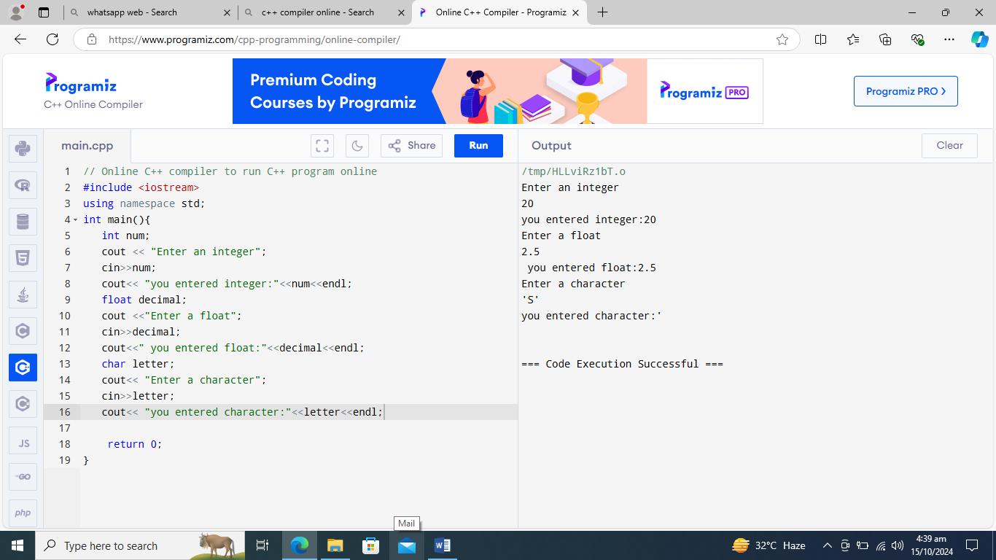

* **Task 03 : Using Assignment operators .**

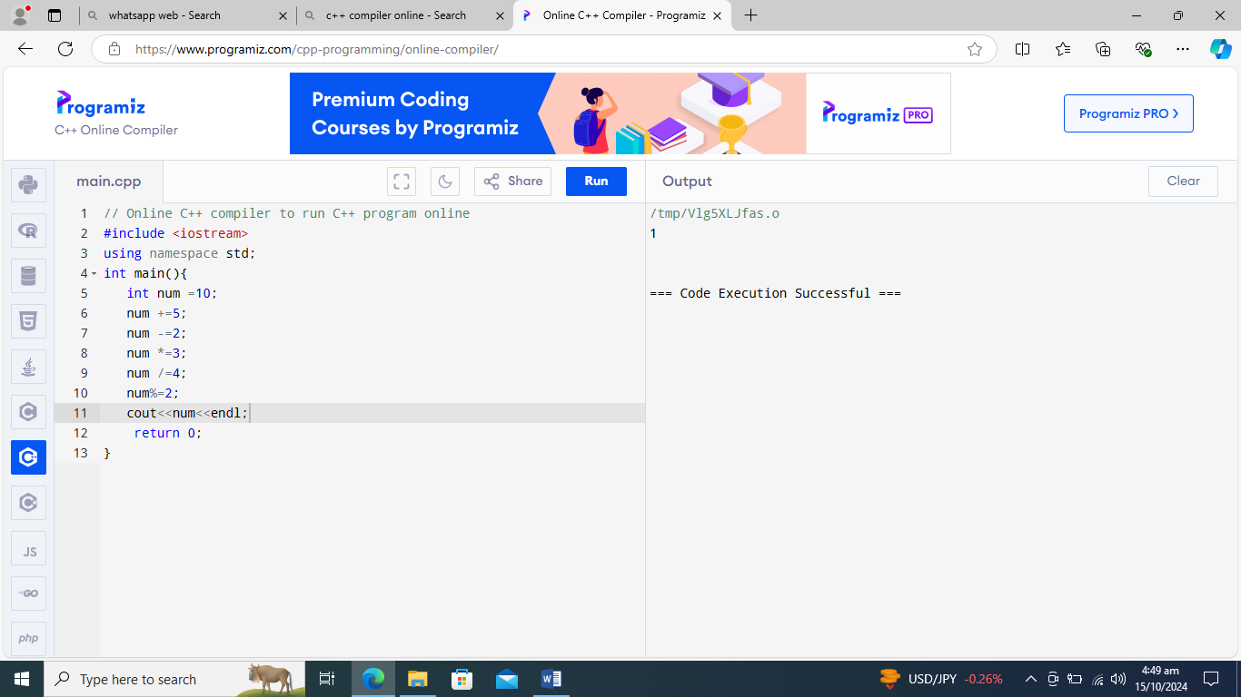

* **Task 04 : Logical operators with Boolean Values .**

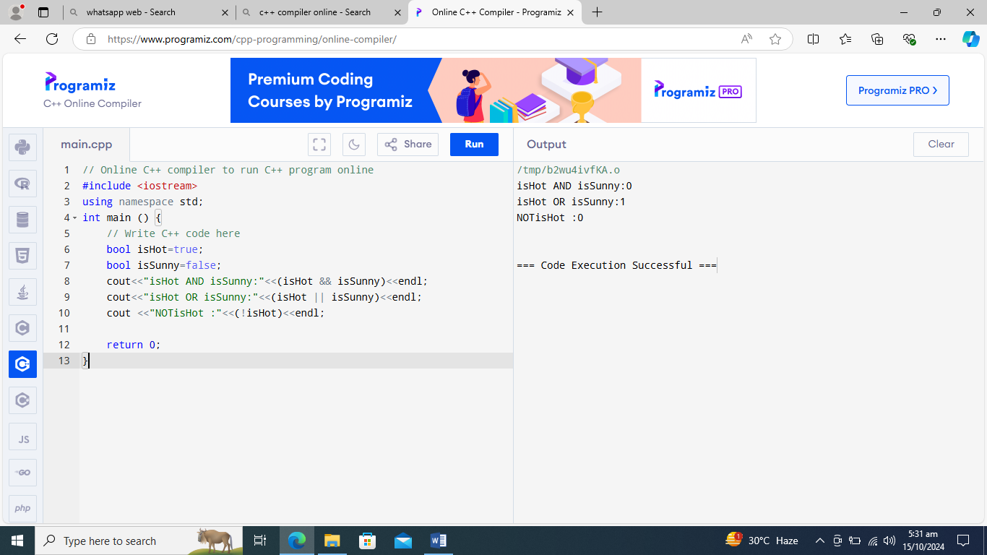

* **Task 05 : Comparison Operators with User Input .**

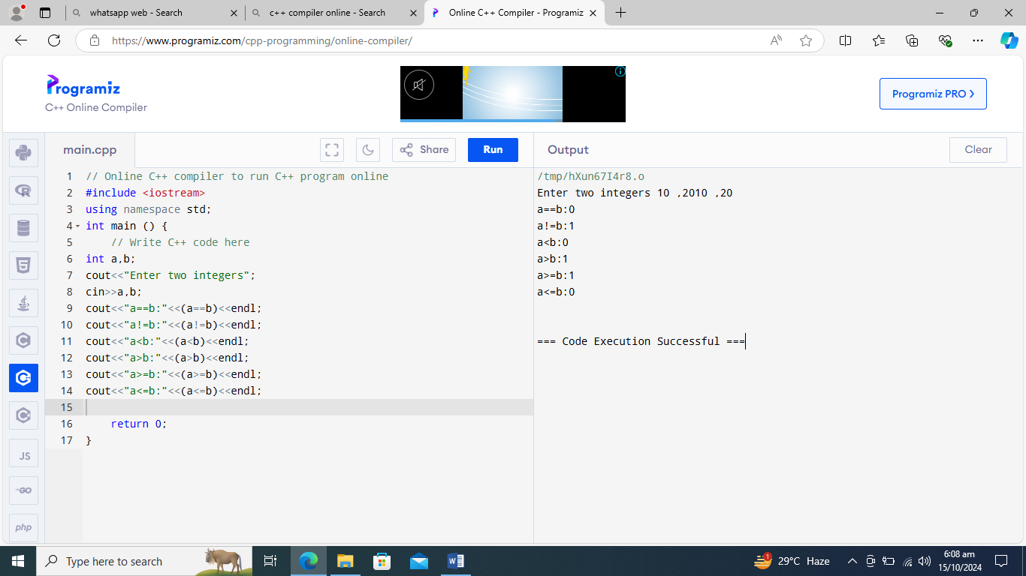

* **Task 06 : Using Ternary operators .**

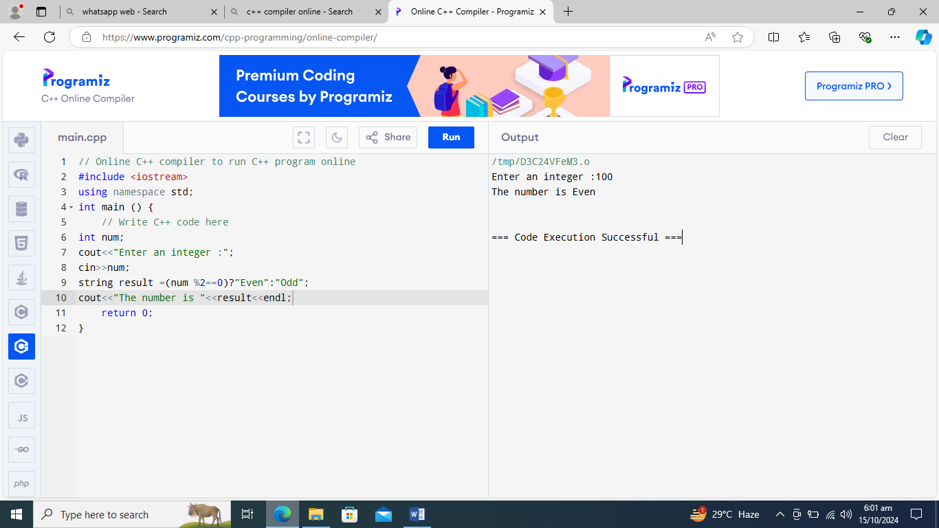

* **Task 07 : Find area of a rectangular garden .**

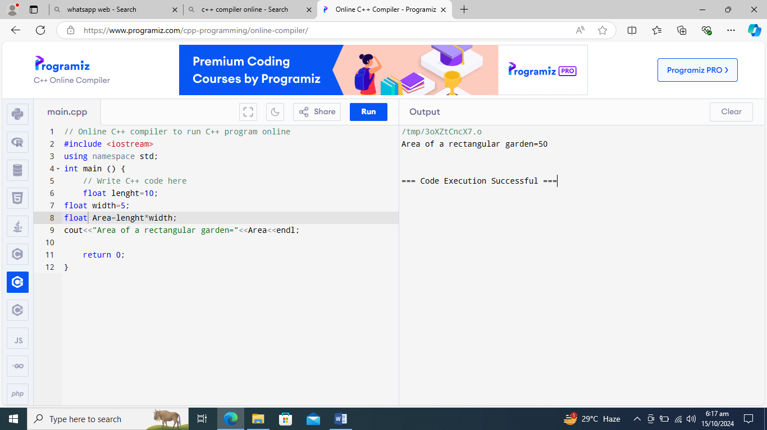

**----The End ----**